**COMPILER DESIGN LAB 6**

**Q1.**

**S --> a | > | ( T )**

**T -->T, S|S**

PROGRAM:

#include <stdio.h>

#include <stdlib.h>

#include <string.h>

int curr = 0;

char str[100];

void S();

void T();

void Tprime();

void invalid()

{

printf("ERROR!\n");

exit(0);

}

void valid()

{

printf("SUCCESS!\n");

exit(0);

}

void S()

{

if (str[curr]== 'a')

{

curr++;

return;

}

else if (str[curr]=='>')

{

curr++;

return;

}

else if ( str[curr]=='(')

{

curr++;

T();

if(str[curr]==')')

{

curr++;

return;

}

else

invalid();

}

else

invalid();

}

void T()

{

S();

Tprime();

}

void Tprime()

{

if (str[curr]== ',')

{

curr++;

S();

Tprime();

return;

}

}

int main()

{

printf("Enter String:");

scanf("%s", str);

S();

if(str[curr]=='$')

valid();

else

invalid();

}  
  
OUTPUT:

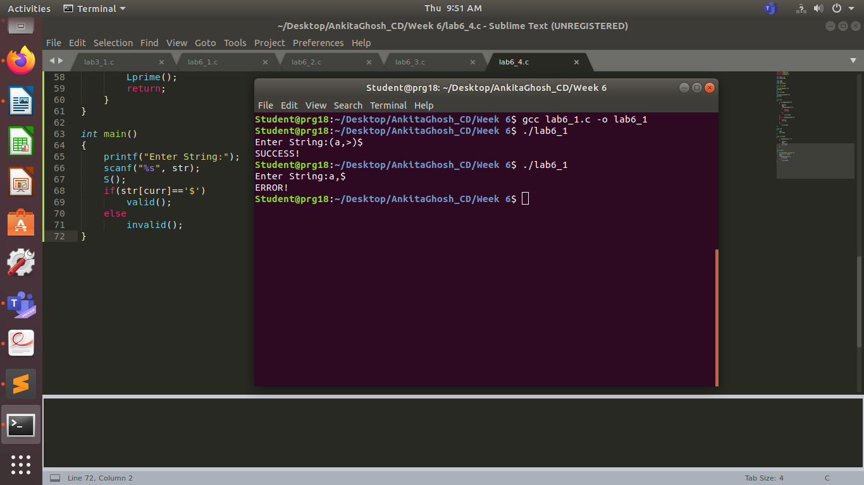

**Q2.**

**S-->UVW**

**U-->(S) | aSb | d**

**V --> aV | ε**

**W --> cW | ε**

PROGRAM:

#include <stdio.h>

#include <stdlib.h>

#include <string.h>

int curr = 0;

char str[100];

void S();

void U();

void V();

void W();

void invalid()

{

printf("ERROR!\n");

exit(0);

}

void valid()

{

printf("SUCCESS!\n");

exit(0);

}

void S()

{

U();

V();

W();

}

void U()

{

if ( str[curr]=='(')

{

curr++;

S();

if(str[curr]==')')

{

curr++;

return;

}

else

invalid();

}

else if ( str[curr]=='a')

{

curr++;

S();

if(str[curr]=='b')

{

curr++;

return;

}

else

invalid();

}

else if ( str[curr]=='d')

{

curr++;

return;

}

else

invalid();

}

void V()

{

if ( str[curr]=='a')

{

curr++;

V();

return;

}

}

void W()

{

if ( str[curr]=='c')

{

curr++;

W();

return;

}

}

int main()

{

printf("Enter String:");

scanf("%s", str);

S();

if(str[curr]=='$')

valid();

else

invalid();

}  
OUTPUT:

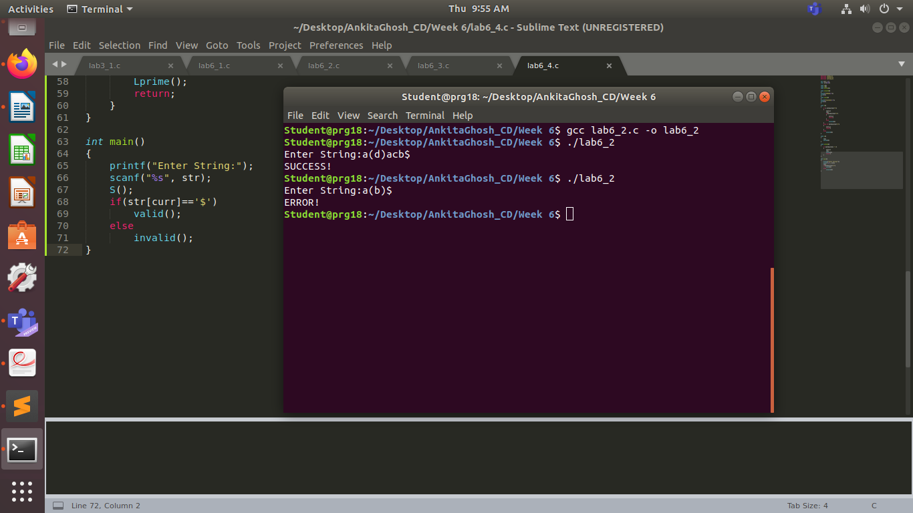

**Q3.**

**S-->aAcBe**

**A-->Ab|b**

**B-->d**

PROGRAM:

#include <stdio.h>

#include <stdlib.h>

#include <string.h>

int curr = 0;

char str[100];

void S();

void A();

void Aprime();

void B();

void invalid()

{

printf("ERROR!\n");

exit(0);

}

void valid()

{

printf("SUCCESS!\n");

exit(0);

}

void S()

{

if (str[curr]=='a')

{

curr++;

A();

if (str[curr]=='c')

{

curr++;

B();

if (str[curr]=='e')

{

curr++;

return;

}

}

}

else

invalid();

}

void A()

{

if (str[curr]=='b')

{

curr++;

Aprime();

return;

}

}

void Aprime()

{

if (str[curr]=='b')

{

curr++;

Aprime();

return;

}

}

void B()

{

if (str[curr]=='d')

{

curr++;

return;

}

else

invalid();

}

int main()

{

printf("Enter String:");

scanf("%s", str);

S();

if(str[curr]=='$')

valid();

else

invalid();

}  
  
OUTPUT:

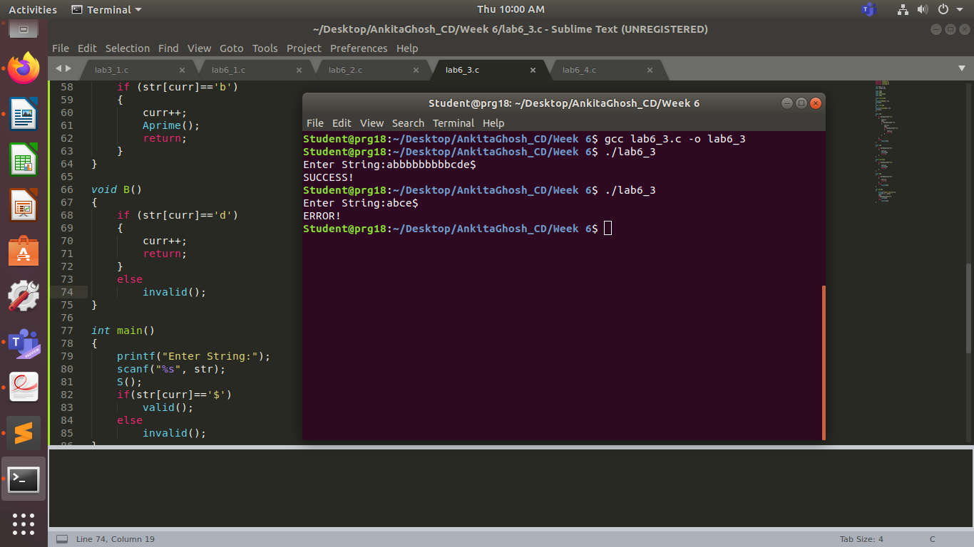

**Q4.**

**S -->(L) | a**

**L --> L,S | S**

PROGRAM:

#include <stdio.h>

#include <stdlib.h>

#include <string.h>

int curr = 0;

char str[100];

void S();

void L();

void Lprime();

void invalid()

{

printf("ERROR!\n");

exit(0);

}

void valid()

{

printf("SUCCESS!\n");

exit(0);

}

void S()

{

if ( str[curr]=='(')

{

curr++;

L();

if(str[curr]==')')

{

curr++;

return;

}

else

invalid();

}

else if (str[curr]=='a')

{

curr++;

return;

}

else

invalid();

}

void L()

{

S();

Lprime();

}

void Lprime()

{

if (str[curr]== ',')

{

curr++;

S();

Lprime();

return;

}

}

int main()

{

printf("Enter String:");

scanf("%s", str);

S();

if(str[curr]=='$')

valid();

else

invalid();

}

OUTPUT:

